***Fatima bint Naseer***

***BSAI_3A_050***

**DFS with stack:**

This Python program implements a **GraphNode** class to represent nodes in a graph, where each node can connect to others. It also includes a **depth-first search (DFS)** function that explores the graph by visiting nodes in depth-first order using a stack. The program creates a sample graph with six nodes and performs a DFS starting from node **A**, printing the visited nodes.

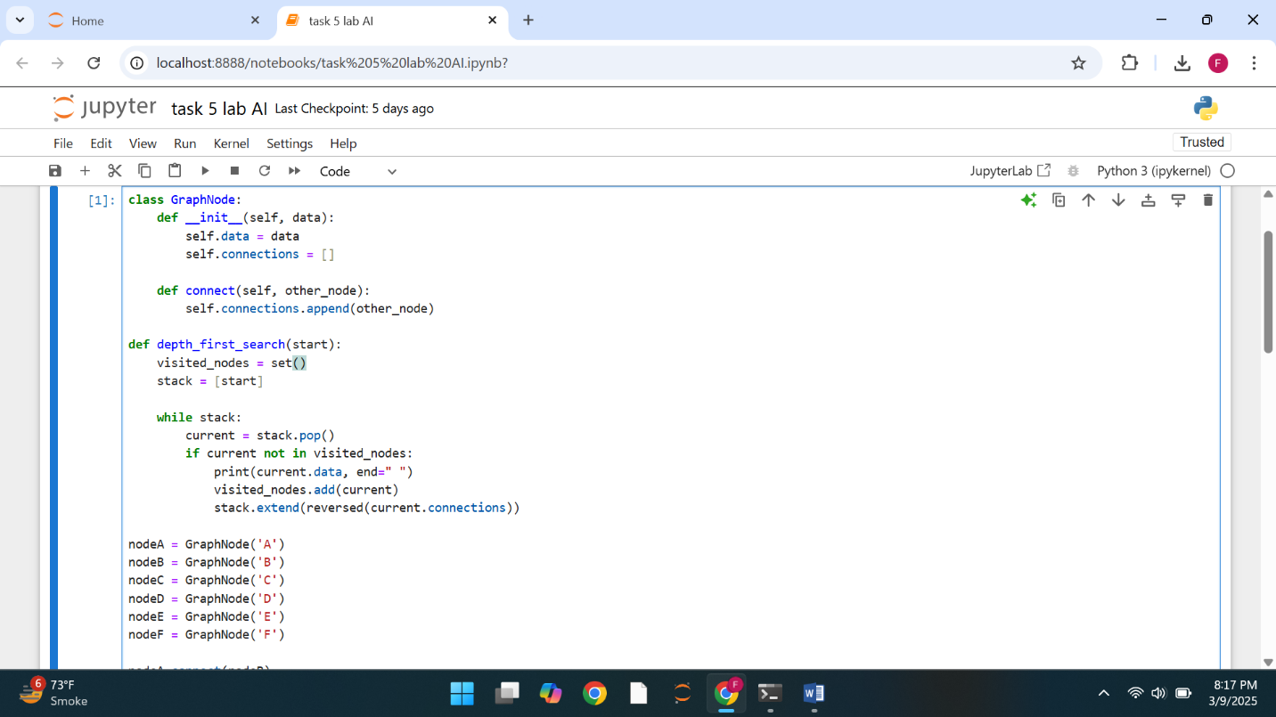

**DFS with node:**

This code creates a simple binary tree and performs three types of depth-first traversals: **inorder, preorder, and postorder**. In **inorder**, nodes are visited in the order: left, root, right. In **preorder**, they are visited as root, left, right, and in **postorder**, the order is left, right, root. The program prints the traversal results for a given tree structure.

